**Stress Learning Games**

**Iteration 0**

* Team members and roles
  + Hanyang Li (Product Owner)
  + Ping Lu (Scrum Master)
  + Xin Hu (Programmer)
  + Zhiyu Yan (Programmer)
  + Chaoyang Zhu (Game Testing)
  + Yipeng Lu (Game Design and Game Testing)
  + Mufeng Xie (Report Editor)
* Customer meeting data/time/place
  + Mondays 2020 Spring Semester, 1:00 – 2:00 pm, EABA
* Summary
  + Customer Need: The customer wants a series of “Stress Learning Games” that would facilitate students to identify and describe the structures and functions of the nervous system, investigate how organisms respond to internal and external stimuli, identify and describe the structures and functions of the endocrine system, and describe how organisms maintain stable internal conditions in response to external and internal stimuli.
  + After carefully reading the materials sent from the customer and talking to the professor, we have formed a general idea of what our application looks like. It’s a game of guessing the correct words given the text hints or pictures provided by the customer. That would be the knowledge base with implicit questions. The correct words are provided randomly among other false answers. The learner/student is supposed to drag the correct words to the boxes at the correct pictures or the correct text hints. If the learner gives the correct answer, he or she would get an immediate feedback or reward in words or sounds etc…See example below in Figure 1.
  + Video link: TBD
  + GitHub repo: TBD
  + Pivotal Tracker: TBD
* User stories
  + Feature: Given a text hint or a picture hint along with some potential answers, if the user drags the correct word(s) to the text hint or picture hint, then he/she would get a reward! If the user drags the wrong word(s) to the text hint or picture, he or she would lose points or get an immediate incorrect feedback.
* User interface

Drag the correct word to the correct place according to the hint below. The user would get immediate correct or incorrect feedback in the form of words, colors, sound, etc.

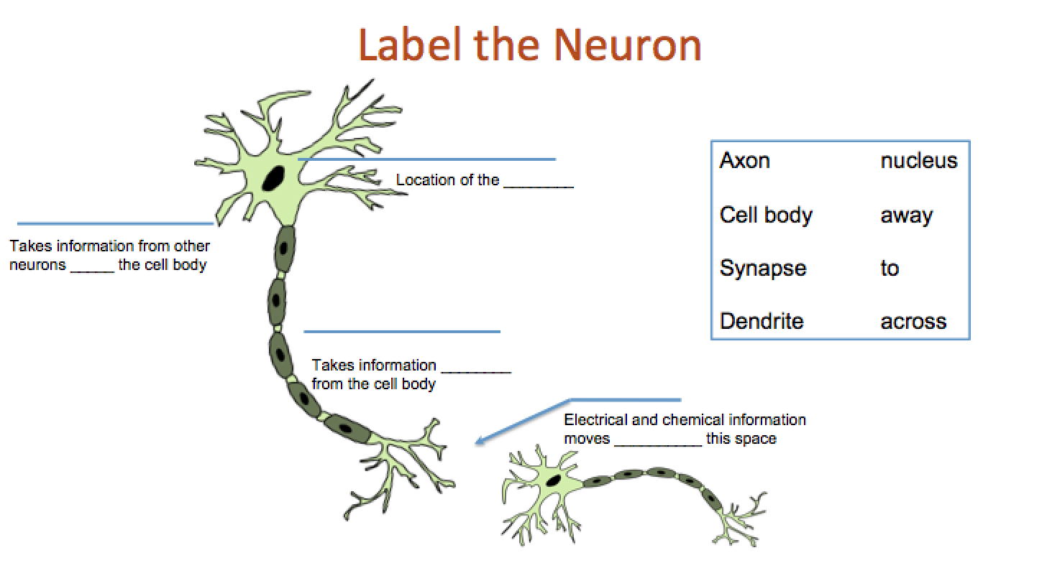

***Figure 1. Label the neuron***